VMWARE VSPHERE MIGRATION

vMotion allows you to move virtual servers and desktops from one physical server to another without having to shut down the virtual desktop or server. All of this is done in real time without the user of the virtual machine even knowing they have been moved. vMotion is the first step among many VMware software solutions that are incorporated to make sure that downtime is kept to a minimum, which include Fault Tolerance, High Availability, and Digital Resource Scheduler.

With vMotion, you can change the host on which a virtual machine is running, or you can change both the host and the datastore of the virtual machine.

When you migrate virtual machines with vMotion and choose to change only the host, the entire state of the virtual machine is moved to the new host. The associated virtual disk remains in the same location on storage that is shared between the two hosts.

When you choose to change both the host and the datastore, the virtual machine state is moved to a new host and the virtual disk is moved to another datastore. vMotion migration to another host and datastore is possible in vSphere environments without shared storage.

After the virtual machine state is migrated to the alternate host, the virtual machine runs on the new host. Migrations with vMotion are completely transparent to the running virtual machine.

The state information includes the current memory content and all the information that defines and identifies the virtual machine. The memory content includes transaction data and the bits of the operating system and applications that are in the memory. The defining and identification information stored in the state includes all the data that maps to the virtual machine hardware elements, such as BIOS, devices, CPU, MAC addresses for the Ethernet cards, chip set states, registers, and so forth.

When you migrate a virtual machine with vMotion, the new host for the virtual machine must meet compatibility requirements so that the migration can proceed.

Migration with vMotion occurs in three stages:

|  |  |
| --- | --- |
| 1 | When the migration with vMotion is requested, vCenter Server verifies that the existing virtual machine is in a stable state with its current host. |
| 2 | The virtual machine state information (memory, registers, and network connections) is copied to the target host. |
| 3 | The virtual machine resumes its activities on the new host. |

If errors occur during migration, the virtual machine reverts to its original state and location.

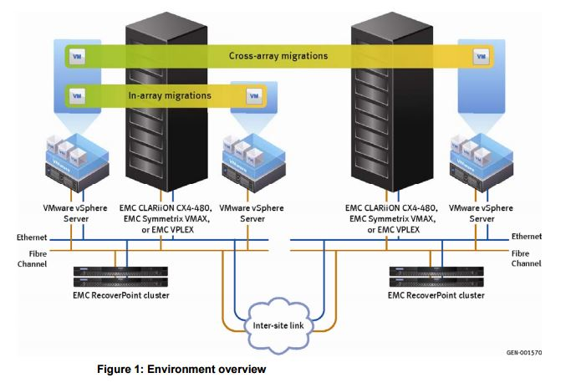

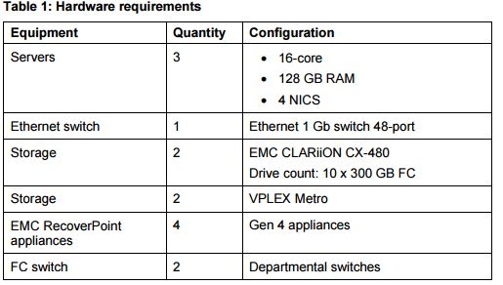

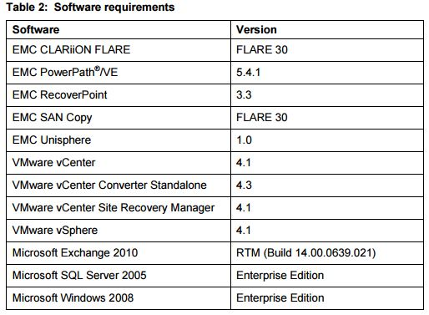

**Pros and Cons of vMotion**

Pros:-

**Automatically optimize and allocate entire pools of resources**

By having all your server and/or desktops virtualized you can move VM’s from one physical host to another, which is done rapidly over a high speed network connection, the original host and destination host stay in sync until the transfer it complete leaving the user unaware of the move. This allows network administrators to easily select resource pools to assign to the different VMs.

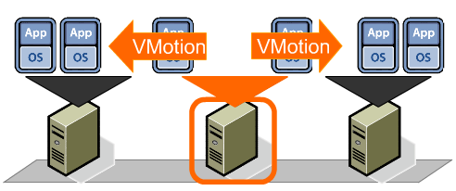

**Move VM’s from failing or underperforming priorities**

If there looks like a server is about to fail or is reaching its capacity, administrators can manually move VMs to another physical host, this allows your data center to be more dynamic in nature. Instead of having to upgrade hardware, you can move VM to another host to allow each VM to be more flexible in nature. If 2 VM's are putting a physical host to capacity then you could move one to another server that isn't being used as much.

**Minimizes scheduled Downtime**

90% of downtime is scheduled, before vMotion administrators had to do server maintenance late at night in order to avoid disrupting users. Having all the servers as virtual machines, you only have to move the VM to another physical host, creating zero downtime for the users and allowing administrators to perform maintenance at any time. With DRS (Digital Resource Manager), all you have to do is put a server in maintanence mode and vMotion will automatically move all VM's to another server.

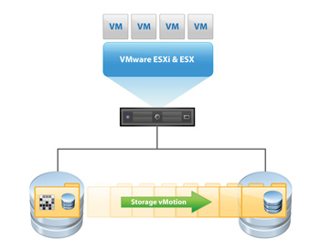

**Storage vMotion**

While technically its own separate feature, it works similar to vMotion, except it deals completely with data. As a VM starts to reach its data capacity, the LUN can easily be moved to a larger storage center. This is done without disruption to the users or having to manually reassigning more space to the VM.

Cons:-

Consider how a virtual machine (VM) works. The VM is turned on, its virtual BIOS boots, and the OS loads and performs various hardware checks. You then start an application in the VM, which may check the capabilities of the hardware and the instructions supported by the processor to enable enhanced functionality. Now imagine this VM is moved, using a zero downtime technology such as vMotion or Live Migration, to a node in the cluster that has an older version of the processor. This older processor is missing a set of instructions that the application found to be available when it performed its hardware check. The VM doesn't know it's been moved to a new virtual host, nor do the OS or the application. The application tries to use some of the enhanced instructions on the CPU, but they're no longer available and the application crashes. This isn't a good scenario.

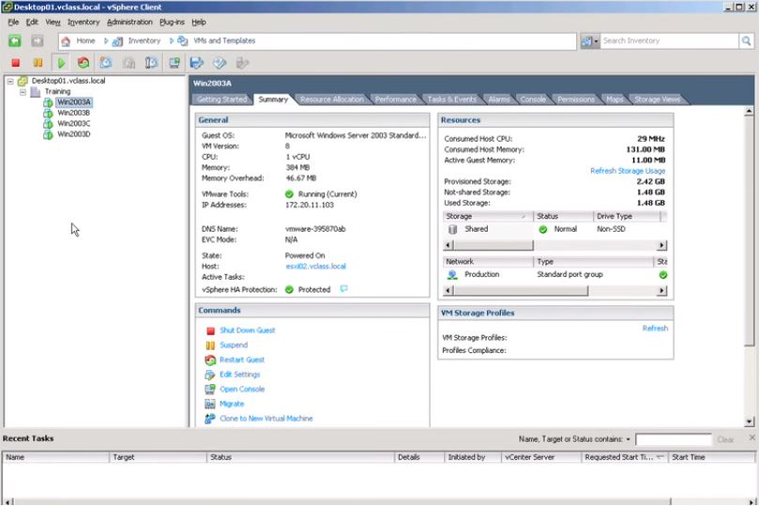**Steps to do Vmotion**

